STA AUTUMN TOUCH LEAGUES

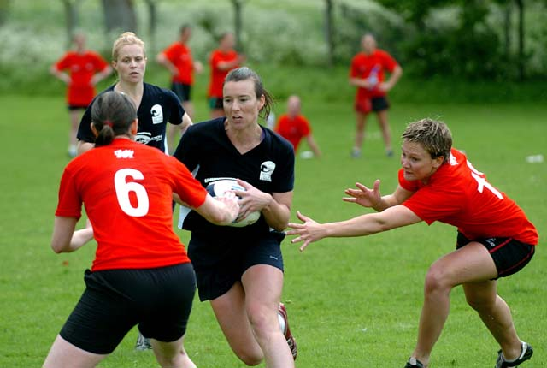

7 MATCHES, 4 NIGHTS OF TOUCH

9TH TO 30TH AUGUST, LISMORE RFC, INCH PARK

ALL PROCEEDS GO TO THE STA
AND THE DEVELOPMENT OF TOUCH IN SCOTLAND
Entry Form

TEAM NAME ………………………………………………….............…………………………………......…….

CONTACT NAME: ………………………………………….............……………………………….....…………
CONTACT EMAIL ADDRESS: ………………………….............………………………………....………….
CONTACT PHONE NUMBER: ……………………….............………………………………....……………

2nd CONTACT NAME: ………………………….............………………………………….……....……………
2nd CONTACT EMAIL ADDRESS: ………………............…………………………….………....………….
2nd CONTACT PHONE NUMBER: ………….............……………………………………....………………

TEAM EXPERIENCE LEVEL (IN SUMMER LEAGUES): ………………............……....…………….

NOMINATED “EMERGENCY REFEREE”……………………….....................……...…………………

PREFERRED LEAGUE: PREMIERSHIP (UPPER)/ CHAMPIONSHIP (LOWER) – delete one

ENTRY FEE: £140 / £160 (delete one - SEE BELOW*)

Tournament Details
- The tournament will be played under Federation of International Touch rules, 3rd ed.
- Games will be played in all weather conditions - team members must ensure appropriate footwear for the relevant conditions. All team members accept that participation is at their own risk (players must arrange their own personal accident insurance if required – payment of entry fee deems acceptance of conditions on behalf of all team members).
- Teams will be divided into a premiership and championship division based on their experience and preference.
- No player movement between “league levels” – any players assisting another team can only help a team entered at the “same league level” (this should be notified to the referee at the start of the game). League levels will be dependent on entries and determined by the organisers based on equivalent BD or ETS level.
- Format will be subject to number of entries but the intention is to play round robin matches culminating in a final for each team. Each final will carry a prize. The team finishing last will win a participation prize.
- Cost per team is £140 which works out at around £1.50 per player for each game played. All proceeds go to the STA.
- *Optionally, at a surcharge of £20, teams may enter a weekly prize raffle for 4 weeks. The £20 each team provides goes towards the cost of sending Scottish referees to the European Touch Championships in September.

Tournament Enquiries
MARK KEEBLE (07768 837268) l_keeble@sky.com
PETER FAASSEN (07814 857 917) peterfaassen@bethere.co.uk

Completed Entry Forms & Cheques Payable to:
Mark Keeble, 8 Woodlands Drive, Bo'ness, West Lothian, EH51 0NT
Or by bank transfer to: Mr Mark Keeble, Sort:- 87-79-11, Account:- 80852368

CLOSING DATE FOR ENTRIES – 5 AUGUST 2012

